**DM2198**

SP1 Game Report

**Digital Entertainment Project**

**Development Team**

**Yin Shuyu ( 150713R )**

**Lim Ngian Xin Terry ( 150496F )**

**Wayne Aw ( 152558X )**

**Chin Hao Ming ( 154158D )**

**Contents**

1. **Introductory to the game**
   1. **Game idea/Concept**
   2. **Description of the game**
2. **Planning**
   1. **Project Schedule**
   2. **Timeline of task breakdown**
3. **Description of features**
4. **Knowledge Applied**
5. **Problems & Experience**
   1. **Problems Encountered & Solved**
   2. **Lessons Learnt**
6. **Future implementations**
   1. **Enhancements/Improvements**

Introductory to the game

1.0

1.1 Game idea/Concept

First and foremost, our game is called the Mummy and it is made to be a 2D-Platformer Puzzle/Maze game. The game is set in the Egyptian Era where a mummy, who is the true king of ancient Egypt, has been revived by the power of the Egyptian gods. However, the mummy woke up to realise that he’s been trapped inside the pyramid by the fake pharaoh that murdered him and used ancient magic to seal him as a mummy. Many obstacles and enemies await the mummy as he tries his hardest to escape the puzzling levels of the pyramid to expose the devious acts of the fake pharaoh and to regain his throne and position as the true ruler of Egypt.

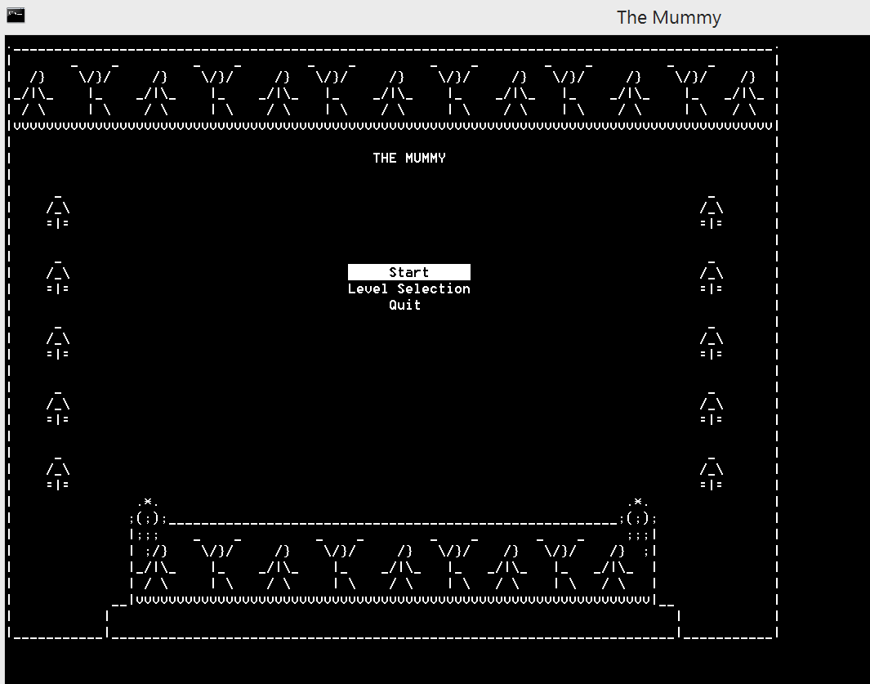

1.2 Description of the game

It is a single player game where the mummy moves by the arrow keys and space button to jump, the mummy would start at the spawn point and the objective is to reach the final portal to advance to the next level but of course it won’t be that easy.

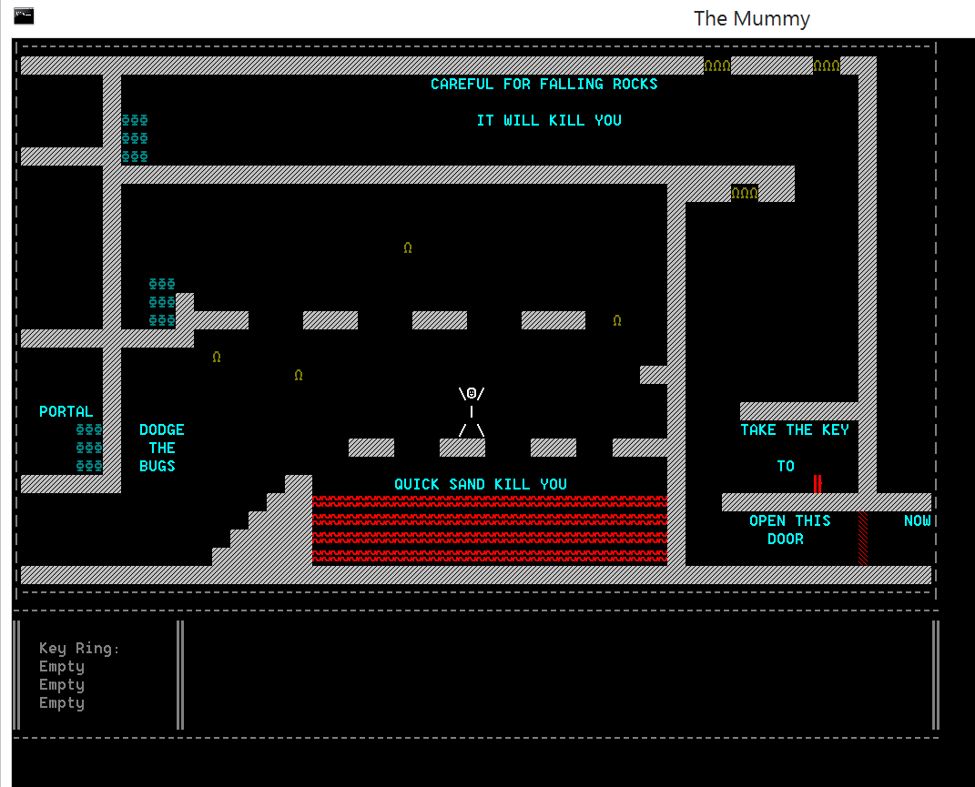

2.0 Planning

2.1 / 2.2 Project Schedule / Timeline

(ESTIMATED)

|  |  |
| --- | --- |
| Gantt chart for project scheduling |  |

|  |  |  |  |  |  |  |  |  |  |  |  |  |  |  |  |  |  |  |  |
| --- | --- | --- | --- | --- | --- | --- | --- | --- | --- | --- | --- | --- | --- | --- | --- | --- | --- | --- | --- |
| Experimenting Mechanics |  |  |  |  |  |  |  |  |  |  |  |  |  |  |  |  |  |  |  |
| Implementing Mechanics |  |  |  |  |  |  |  |  |  |  |  |  |  |  |  |  |  |  |  |
| Improving Mechanics/Project Done |  |  |  |  |  |  |  |  |  |  |  |  |  |  |  |  |  |  |  |
| Finishing touches/presentation & report |  |  |  |  |  |  |  |  |  |  |  |  |  |  |  |  |  |  |  |
| Days | 1 | 2 | 3 | 4 | 5 | 6 | 7 | 8 | 9 | 10 | 11 | 12 | 13 | 14 | 15 | 16 | 17 | 18 | 19 |

(ACTUAL)

|  |  |
| --- | --- |
| Gantt chart for project scheduling |  |

|  |  |  |  |  |  |  |  |  |  |  |  |  |  |  |  |  |  |  |  |
| --- | --- | --- | --- | --- | --- | --- | --- | --- | --- | --- | --- | --- | --- | --- | --- | --- | --- | --- | --- |
| Experimenting Mechanics |  |  |  |  |  |  |  |  |  |  |  |  |  |  |  |  |  |  |  |
| Implementing Mechanics |  |  |  |  |  |  |  |  |  |  |  |  |  |  |  |  |  |  |  |
| Improving Mechanics/project done |  |  |  |  |  |  |  |  |  |  |  |  |  |  |  |  |  |  |  |
| Finishing touches/presentation & report |  |  |  |  |  |  |  |  |  |  |  |  |  |  |  |  |  |  |  |
| Days | 1 | 2 | 3 | 4 | 5 | 6 | 7 | 8 | 9 | 10 | 11 | 12 | 13 | 14 | 15 | 16 | 17 | 18 | 19 |

3.0 Description of features

* Teleporters
* Side Scrolling (The camera focuses on the character)
* Buttons that open walls
* Gravity
* Jumping (up arrow key)
* Poisonous Bugs (Monsters that roams linearly back and forth and will bounce back when collided with an object EG BOX)
* Inventory system (will update upon acquiring the keys or using the keys)
* Keys (will be picked up when player walks over them)
* Doors (Will disappear along with keys if the key is used)
* Boxes (Can be pushed or pulled, remove quick sand, repel monsters and some boxes can defy gravity.)
* Print Messages (will list out the events happening and will stay there until 4 events maximum (EG. You have received a Red Key!))
* Level Selection during main menu screen
* Game pause/continue during gameplay
* Falling rocks (When touched , it will respawn you to your initial spawn point)
* Lava (When touched , it will respawn you to your initial spawn point)

* Respawn to the starting point of you die
* Level can be restarted by pressing the ‘R’ button

C++

4.0 Knowledge applied

* Functions
* Arrays
* Structs
* Headerfiles
* Externs
* Loops
* Minimised Hard-coding
* Reading from .txt file
* Pointers
* Indentations and commenting
* Version control system

5.0 Problems & Experience

5.1 Problems encountered / solved

We encountered multi-problems during our game-making . The biggest problem we encountered was probably the camera which was the side-scrolling, and we had to ensure that the camera constantly render the map and character on the same area in the console, but at the same time ensure that the character and item collided properly with other another and the map. There was a huge problem where the collision would not update along with the camera, and the player would walk through walls and collide into empty space.In order to solve this, we had to create an Array called g_worldGrid, which helped us keep track of where the walls are and where to render them. It even allowed us to load the map into the game using a .txt file, as well as handle collisions and picking up items for the rest of the game.

Secondly, we also had problems using the version control system . Most notably called Smart-Git , it is a program that allows us to commit and push/pull which is receiving and uploading our codes, we were completely clueless on using it at the start even despite the instructions uploaded by our lecturers but as time went on , we managed to solve our problem of not knowing how to use Smart-Git. We even lost some of our codes when we’re trying to merge the codes together , it did slow us down but it didn’t really impact us much.

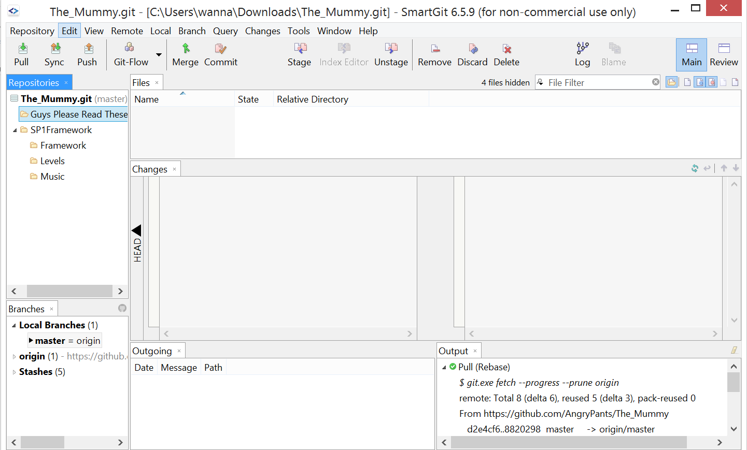

5.2 Lessons learnt

Backing up codes. One of our members actually lost his codes while merging using smart-git and as he didn’t back up his codes, he lost them and had to do it again.

6.1 Future enhancements

6.0 Future implementations

* More levels
* The ability to save game status
* Checkpoints
* Level Editor